Raspberry Pi

# Introduction:

Raspberry Pi is a series of credit card-sized single board computer developed in UK by Raspberry Pi foundation to promote computer science education in schools and developing countries.

The latest of Raspberry Pi series is Raspberry Pi 3 which includes 1.2GHz 64bit quad core processor with 1 GB of ram on a Broadcom Chip.

Raspberry Pi 3 has a pinout of 40 GPIO.

# Useful stuff:

* I you do not want to connect LCD with Raspberry Pi for display you can install xrdp in Raspberry Pi which can mirror the display of Raspberry Pi on PC. You can install xrdp in Raspberry Pi by typing following command in terminal:

sudo apt-get install xrdp

* For checking ports available for communication following commands can be used in terminal :

ls -l /dev/ttyUSB0  
  
ls -l /dev/tty/ACM0

* Install these two packages for communication between devices

sudo apt-get install python-pip python-serial

sudo pip install pyfirmata

* GPIO pinout:

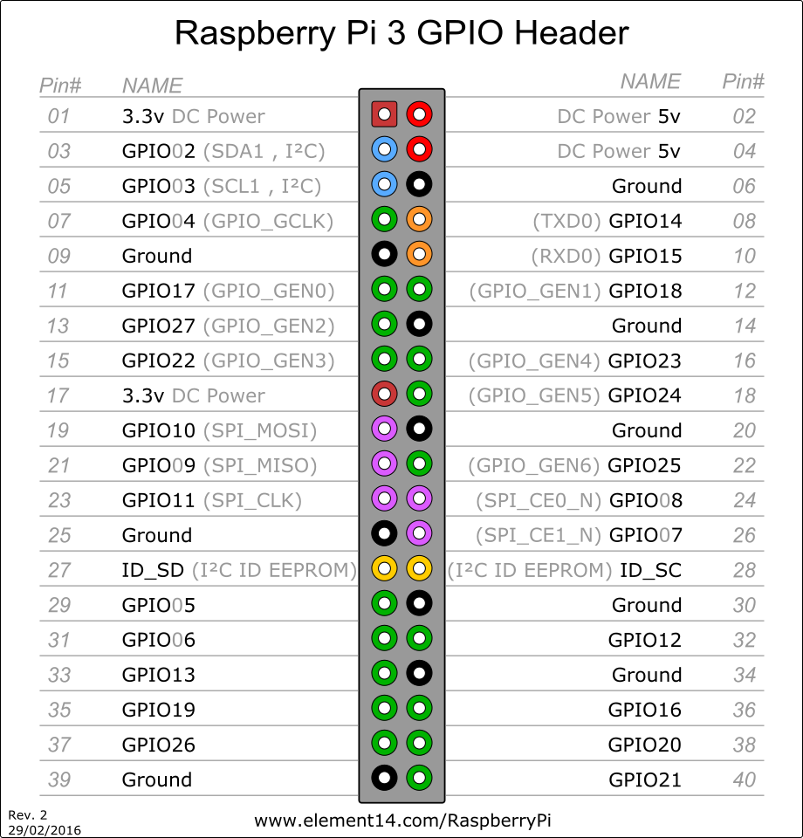

# Task:

In this tutorial we will try to establish communication between Arduino and Raspberry Pi via USB cable. This type of communication is known as Serial Communication.

* First we will upload Standard Firmata on Arduino to make communication simpler. Firmata helps in eliminating Arduino side coding.

To upload Standard Firmata open Arduino IDE and attach Arduino to PC.

Go to File->Examples->Firmata->Standard Firmata and upload the code.

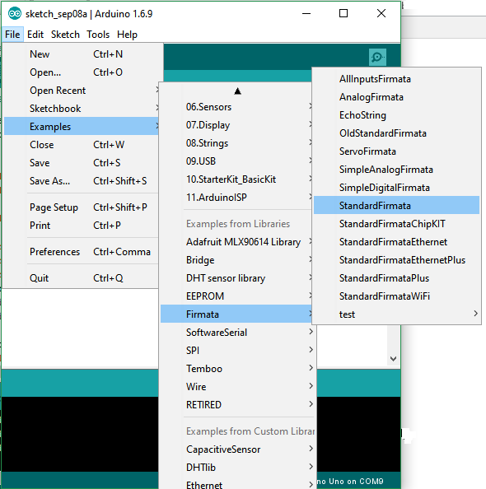

* Now connect Potentiometer to Arduino and Arduino to Raspberry Pi via USB cable as shown in below figure.

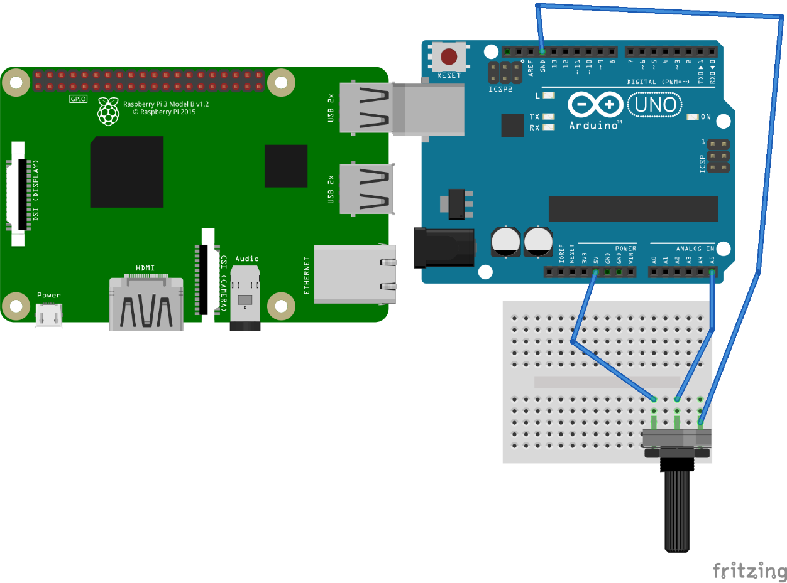

* Open terminal in Raspberry Pi and type the script (given in useful stuff section) for checking port at which Arduino is connected.
* Open Python 3 in Raspberry Pi and make new file.
* Enter following code and run the script.
* Replace the port with the port you found by using script in terminal.

**from** **pyfirmata** **import** Arduino, util

board **=** Arduino('/dev/ttyUSB0')

it **=** util**.**Iterator(board)

it**.**start()

board**.**analog[5]**.**enable_reporting()

value= board**.**analog[5]**.**read()

print(“Potentiometer Value:”,value)

it**.**start()